Badminton in Thame
Q4 Newsletter 2021

We have successfully re-established the club and are looking forward to the next quarter. While the summer is always difficult to predict we can now see that there is a core number of members who show up during the week regularly. For various reasons there are players who have expressed interest in playing but haven’t managed to show up through the summer period; hopefully that has passed, and we can see an upturn in the number of regular players. We mention this because this is what determines the number of courts we book and the type of shuttles we can afford.

A big thank you and welcome to all the new Juniors & Improvers who have recently joined us on Tuesday evenings. It won’t be long before they join in on the other sessions.

Calendar Events
We will be booking the courts in advance for Q4 of this year. We intend to continue playing on Tuesdays, Wednesdays, and Sundays.

One for the diary is we will be arranging a social evening on Wednesday, 1 December 2021 at a venue in Thame to be confirmed. Once we confirm the details, we will make an announcement.

The Oxfordshire and Aylesbury leagues will be starting in October of this year which means everyone’s Badminton England membership must be up to date to be eligible to play. This extends to everyone who plays as a club player.

More importantly, for those who intend to play matches this must be done before the end of September 2021.

The Badminton England & Oxfordshire County annual fees are as follows.

Adults: £12.00 + £2.50 (Oxfordshire fees)
Juniors: £4.00 + £2.50 (Oxfordshire fees)

We will be collecting fees this week and registering you on Badminton England. It is cheaper if we register you through the club than if you register independently.

Important Match Play Notice
We will be selling Match Play Cards in advance of fixtures. Match fees are £7 for home and away matches. You will be expected to purchase any number of match fees prior to playing a match and your team captain will strike off a payment when you play. We will not accept cash so please ensure you have pre-paid your match fees.

Any unused fees are refundable.

We have updated our website calendar with the matches to the end of this year.

Membership
We intend to hold membership fees at the same levels for Q4 despite an increase in court fees and shuttles.

Starting January 2022, it is inevitable that we must increase fees across the board. All fees will be increased by £1. We have managed to keep fees at this level for several years thanks to your support.

We will remind you and publish the new fees later this year.

Thank you for your understanding and continued support throughout this unprecedented period.

Kind regards

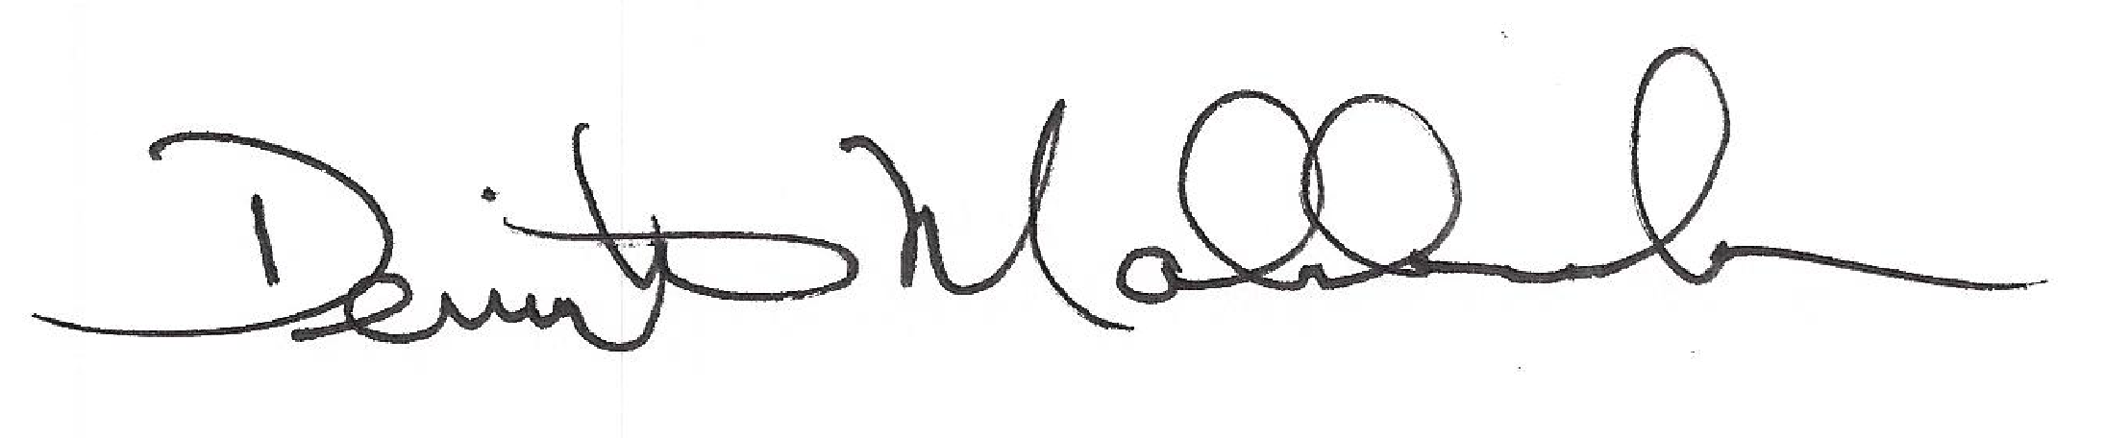

Demi

